Mixed-Shape Composite Solids Formed by Addition

Definition
# Source: AI Source: Provided by: [Data Path: Persons Table -> ID Column: 1, Name_En Column: Motasem Essam] -> From: [ChatGPT] on [7/25/2026]
Mixed-Shape Composite Solids are three-dimensional geometric solids formed by combining two or more components belonging to different geometric solid types.
Unlike prism-based, cylinder-based, cone-based, pyramid-based, or sphere-based composite solids, mixed-shape composite solids contain different categories of solids within the same structure.
Their components may include:
- Prisms.
- Cylinders.
- Cones.
- Pyramids.
- Spheres.
- Hemispheres.
- Other geometric solids.
The components can be connected through matching faces, partial contact regions, or other suitable joining arrangements to create a single composite structure.

Simple Definition
# Source: AI Source: Provided by: [Data Path: Persons Table -> ID Column: 1, Name_En Column: Motasem Essam] -> From: [ChatGPT] on [7/25/2026]
A mixed-shape composite solid is a 3D shape made by joining two or more different types of geometric solids.

Geometric Representation
# Source: AI Source: Provided by: [Data Path: Persons Table -> ID Column: 1, Name_En Column: Motasem Essam] -> From: [ChatGPT] on [7/25/2026]
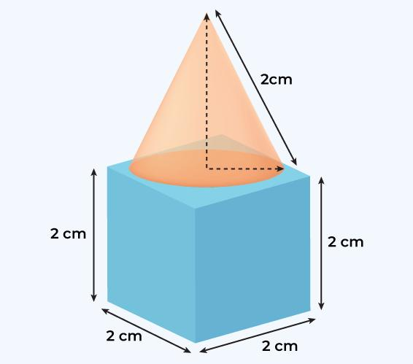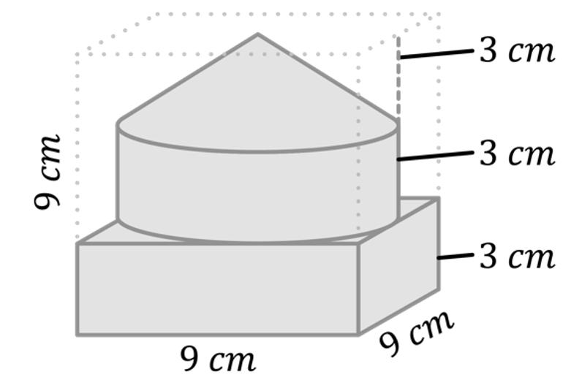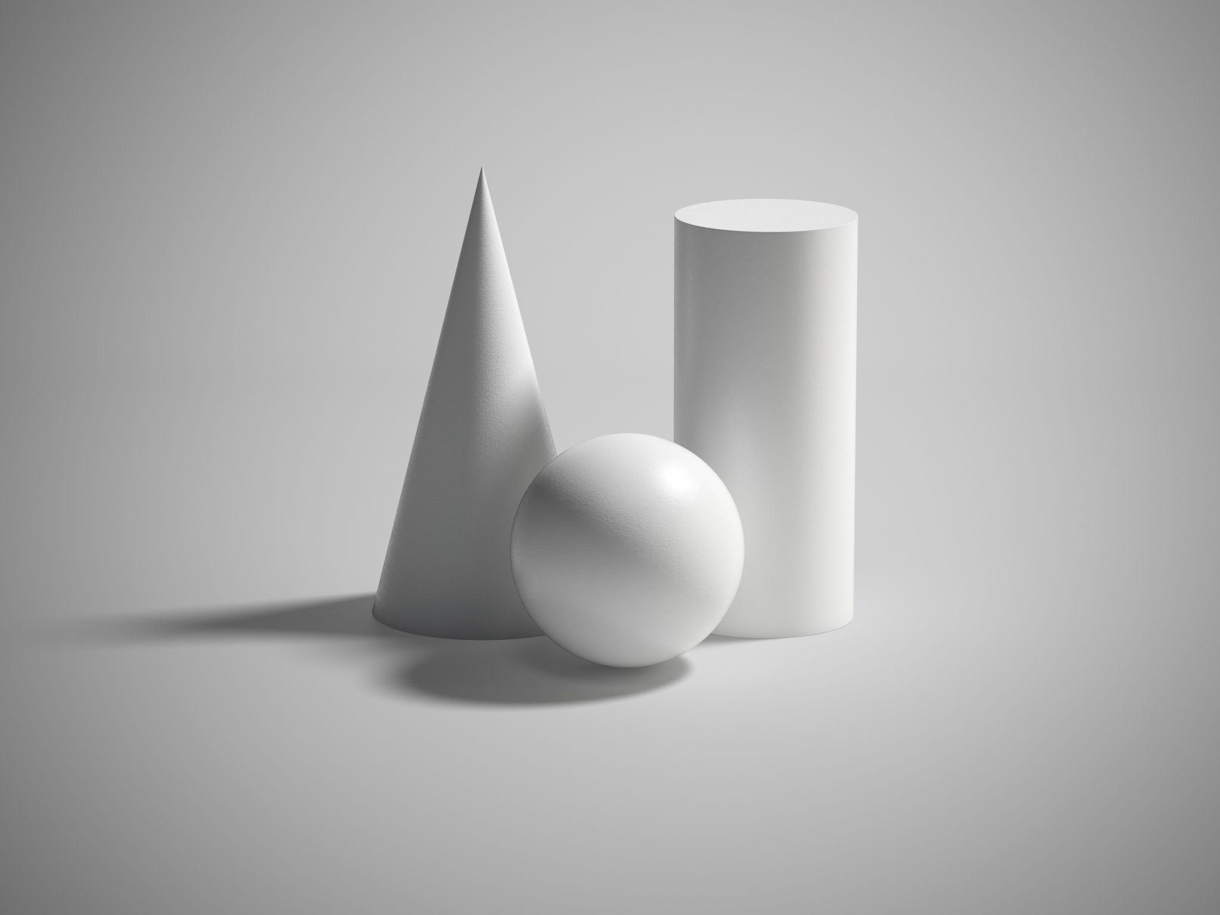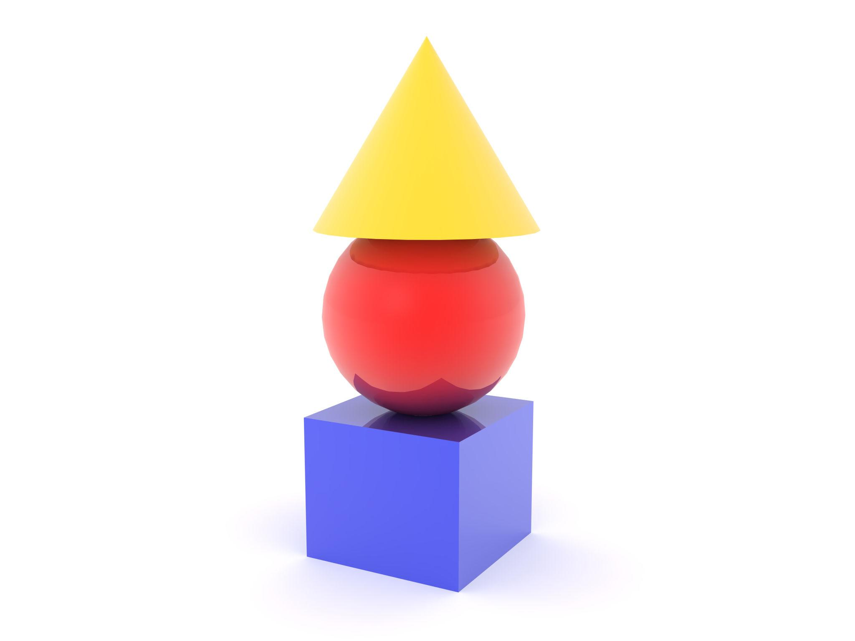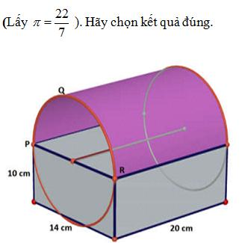
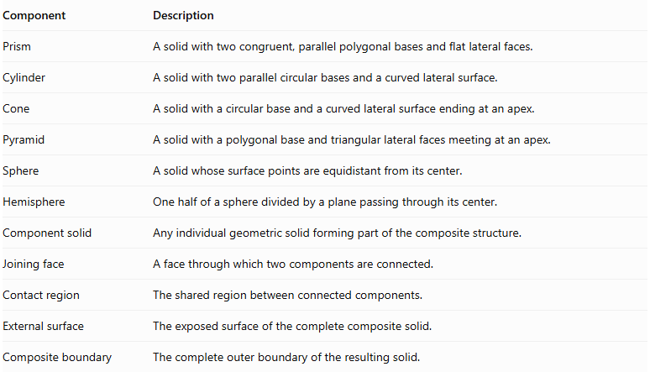
Component | Description
Prism | A solid with two congruent, parallel polygonal bases and flat lateral faces.
Cylinder | A solid with two parallel circular bases and a curved lateral surface.
Cone | A solid with a circular base and a curved lateral surface ending at an apex.
Pyramid | A solid with a polygonal base and triangular lateral faces meeting at an apex.
Sphere | A solid whose surface points are equidistant from its center.
Hemisphere | One half of a sphere divided by a plane passing through its center.
Component solid | Any individual geometric solid forming part of the composite structure.
Joining face | A face through which two components are connected.
Contact region | The shared region between connected components.
External surface | The exposed surface of the complete composite solid.
Composite boundary | The complete outer boundary of the resulting solid.

Types of Mixed-Shape Composite Solids

Prism-and-Cylinder Composite Solids
# Source: AI Source: Provided by: [Data Path: Persons Table -> ID Column: 1, Name_En Column: Motasem Essam] -> From: [ChatGPT] on [7/25/2026]
These solids combine at least one prism with one or more cylindrical components.
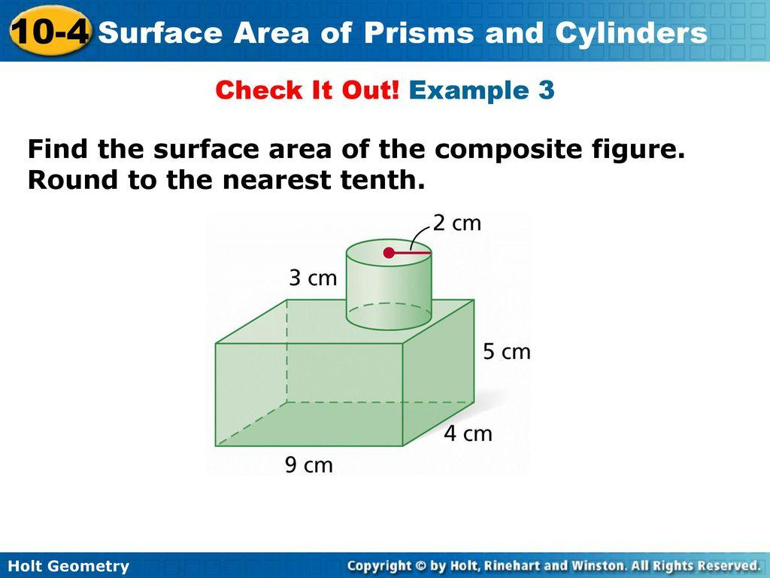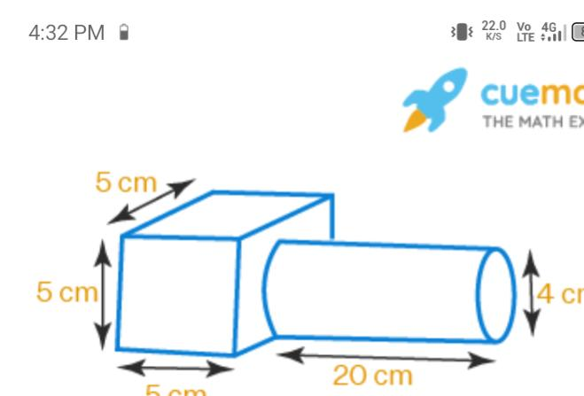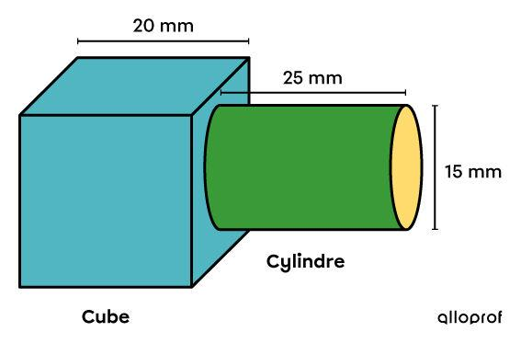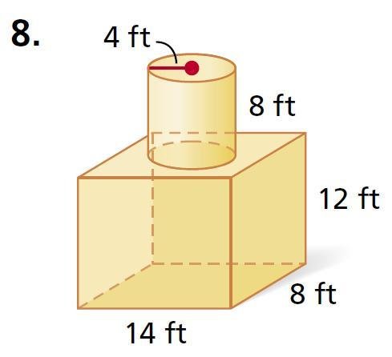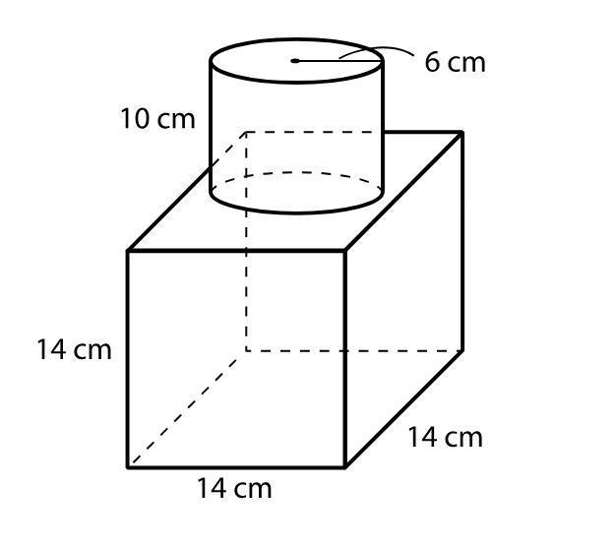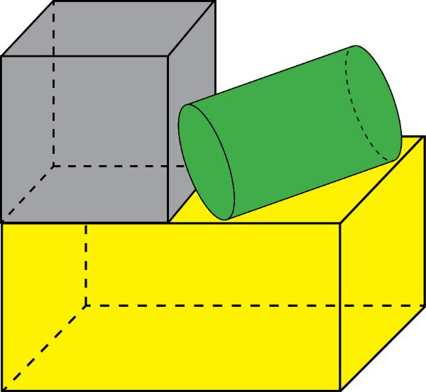
Examples:
- Rectangular prism + cylinder.
- Cube + cylinder.
- Triangular prism + cylinder.
- Multiple prisms connected with cylindrical sections.

Prism-and-Cone Composite Solids
# Source: AI Source: Provided by: [Data Path: Persons Table -> ID Column: 1, Name_En Column: Motasem Essam] -> From: [ChatGPT] on [7/25/2026]
These solids combine polygonal prism components with conical components.
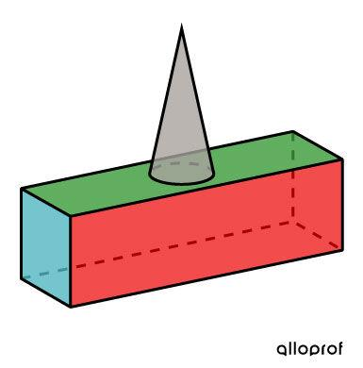
Examples:
- Square prism + cone.
- Rectangular prism + cone.
- Triangular prism + cone.
- Multiple prisms combined with conical sections.

Prism-and-Pyramid Composite Solids
# Source: AI Source: Provided by: [Data Path: Persons Table -> ID Column: 1, Name_En Column: Motasem Essam] -> From: [ChatGPT] on [7/25/2026]
These solids combine prisms with pyramids that may have matching or different polygonal bases.
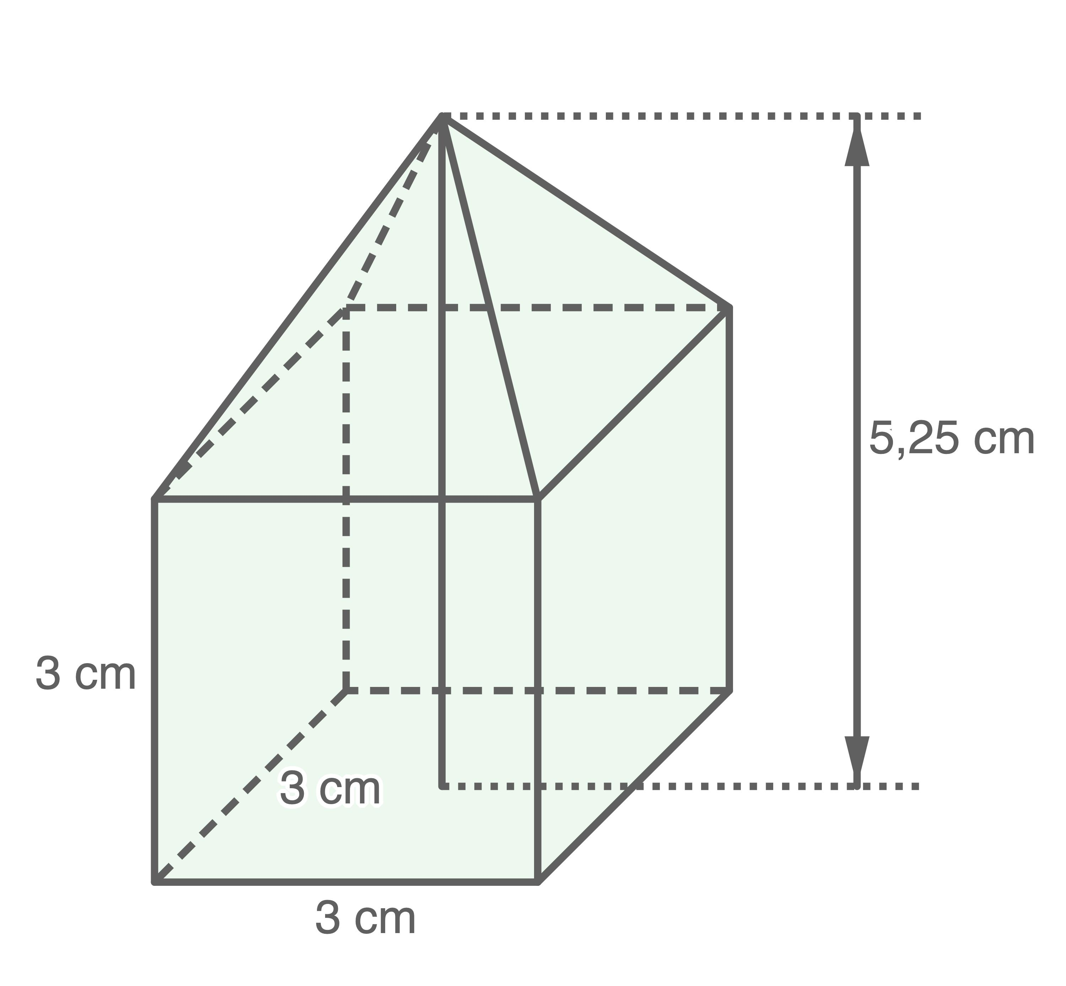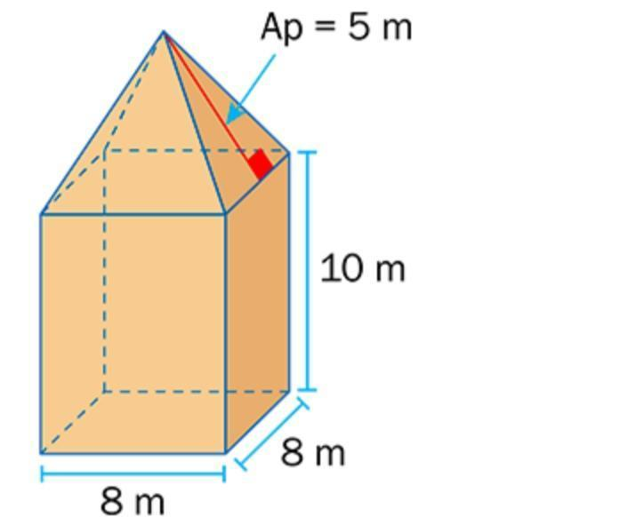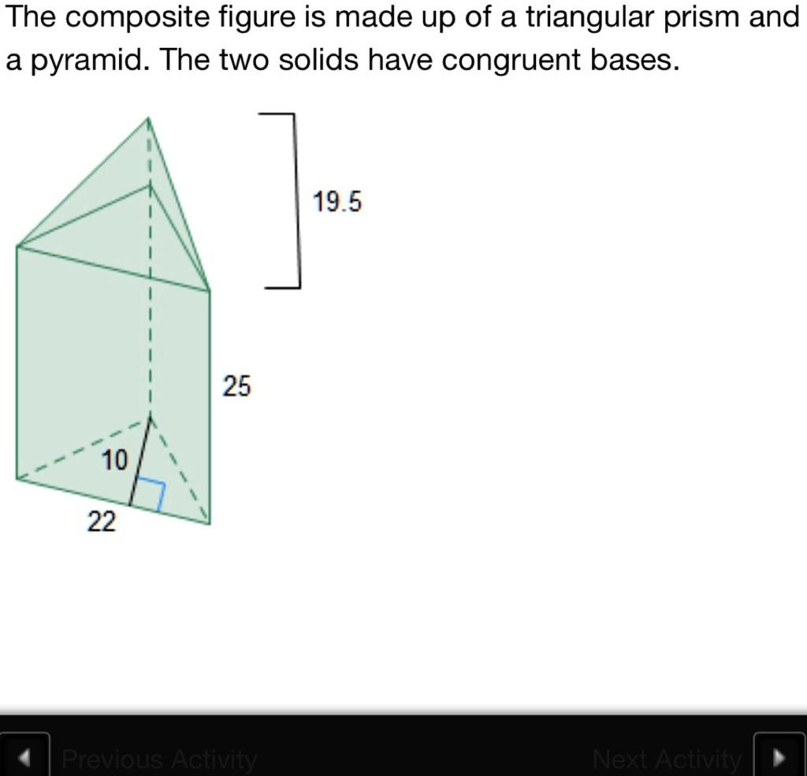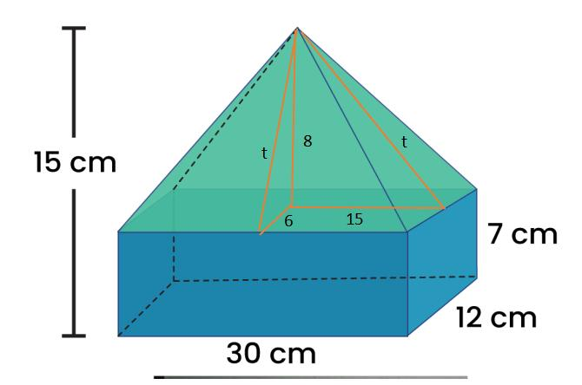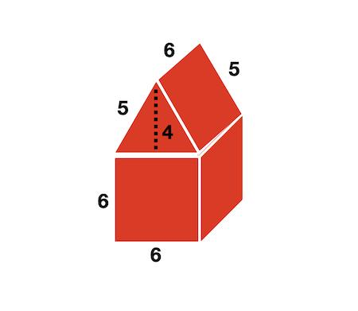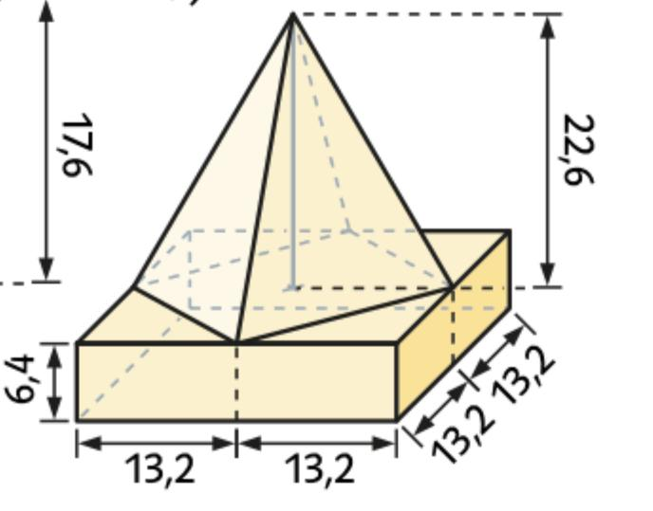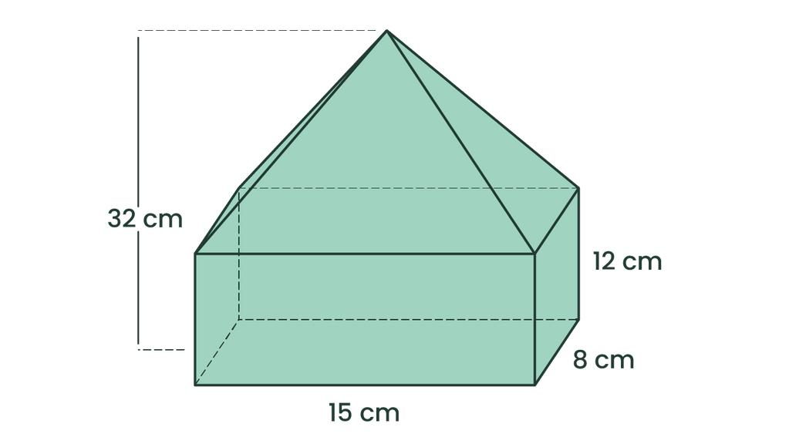
Examples:
- Cube + square pyramid.
- Rectangular prism + rectangular pyramid.
- Triangular prism + triangular pyramid.
- Multiple pyramids attached to prism faces.

Prism-and-Sphere Composite Solids
# Source: AI Source: Provided by: [Data Path: Persons Table -> ID Column: 1, Name_En Column: Motasem Essam] -> From: [ChatGPT] on [7/25/2026]
These solids combine prism components with spherical components or spherical sections.
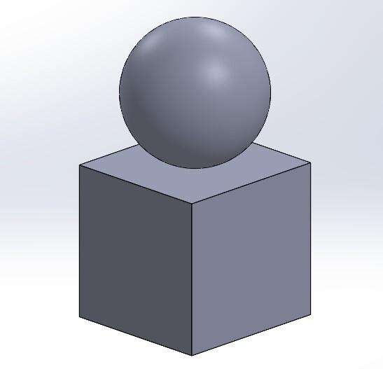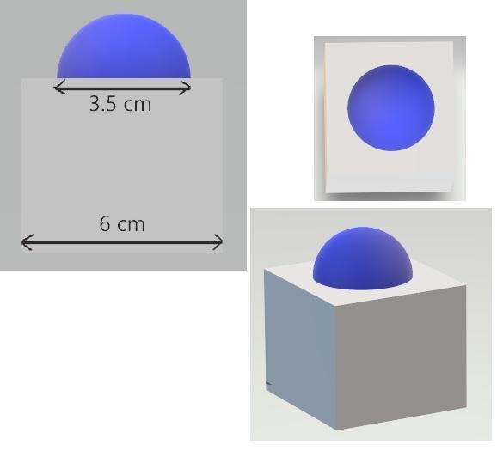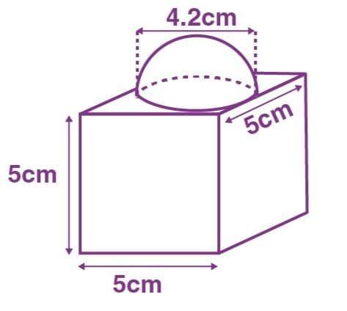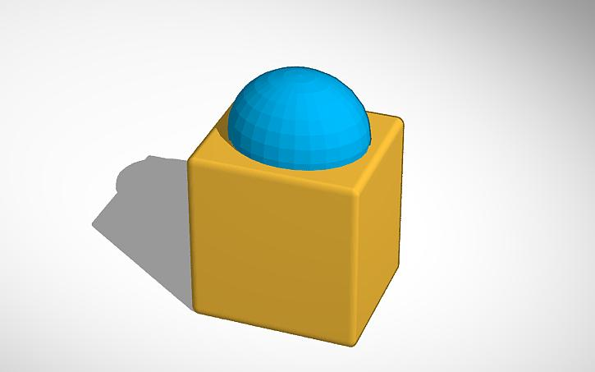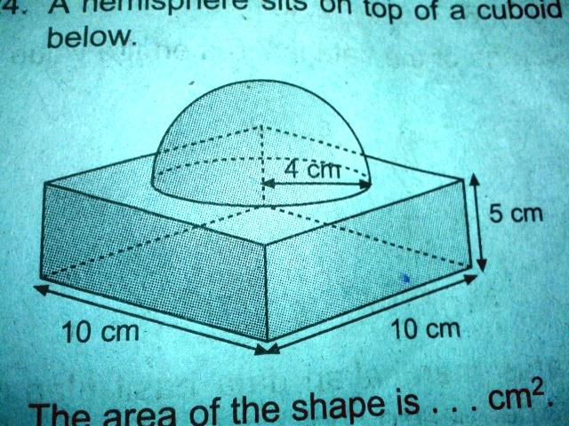
Examples:
- Cube + sphere.
- Rectangular prism + hemisphere.
- Square prism + spherical cap.
- Multiple spheres attached to a prism.

Cylinder-and-Cone Composite Solids
# Source: AI Source: Provided by: [Data Path: Persons Table -> ID Column: 1, Name_En Column: Motasem Essam] -> From: [ChatGPT] on [7/25/2026]
These solids combine cylindrical and conical components, often sharing a circular joining face.
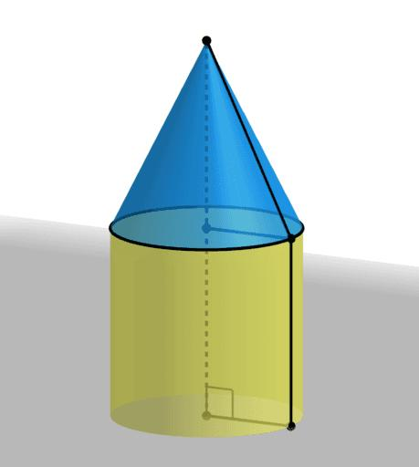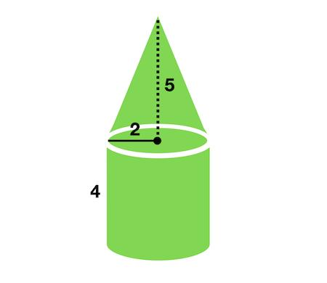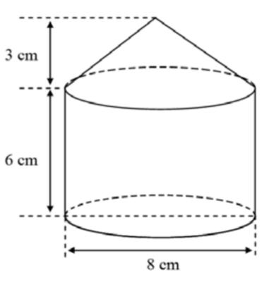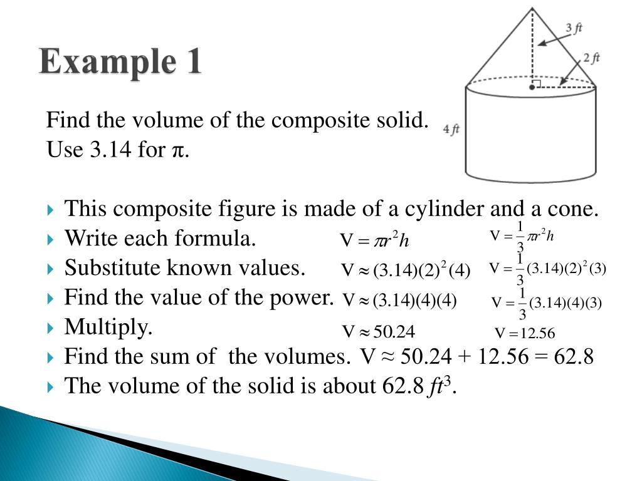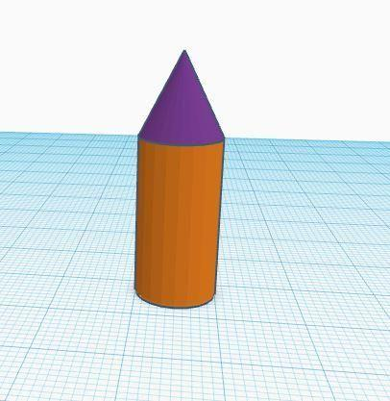
Examples:
- Cylinder + cone.
- Cylinder + two cones.
- Multiple cylindrical sections combined with conical sections.
- Cone attached to the end of a cylinder.

Cylinder-and-Sphere Composite Solids
# Source: AI Source: Provided by: [Data Path: Persons Table -> ID Column: 1, Name_En Column: Motasem Essam] -> From: [ChatGPT] on [7/25/2026]
These solids combine cylindrical components with complete spheres, hemispheres, or spherical sections.
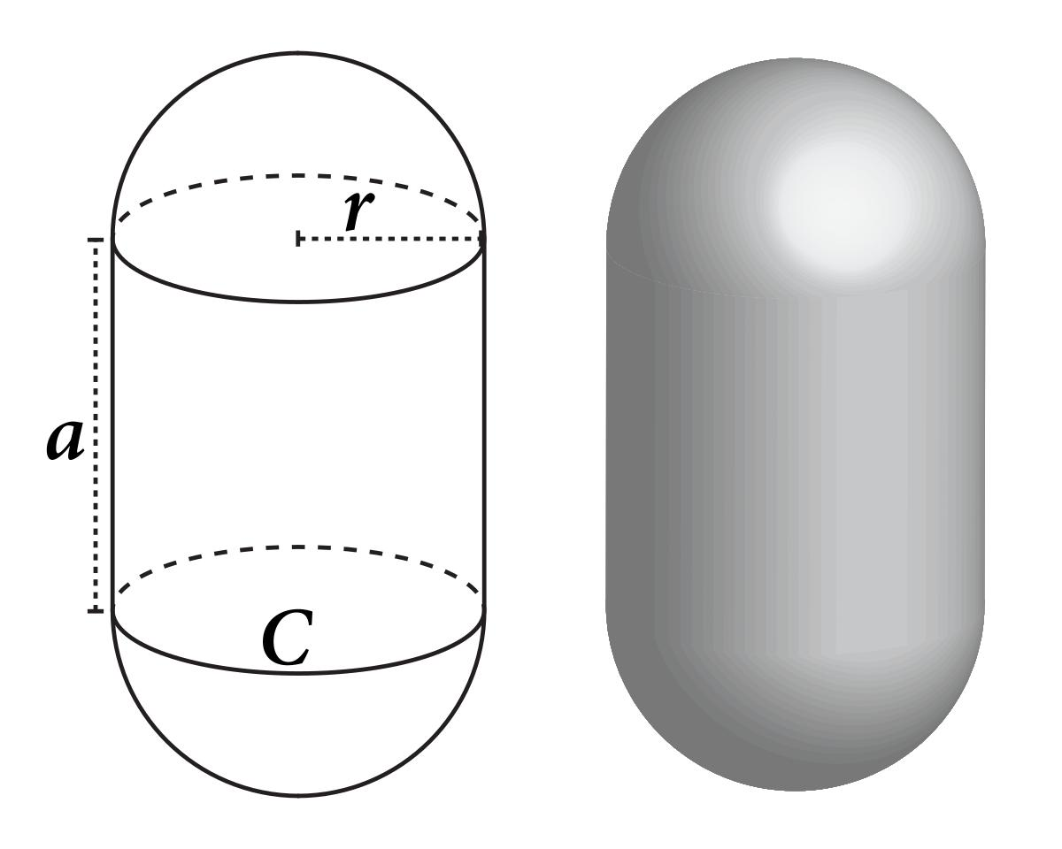
Examples:
- Cylinder + sphere.
- Cylinder + hemisphere.
- Cylinder with two hemispherical ends.
- Multiple cylinders connected to spherical components.

Cone-and-Pyramid Composite Solids
# Source: AI Source: Provided by: [Data Path: Persons Table -> ID Column: 1, Name_En Column: Motasem Essam] -> From: [ChatGPT] on [7/25/2026]
These solids combine conical components with pyramid components.
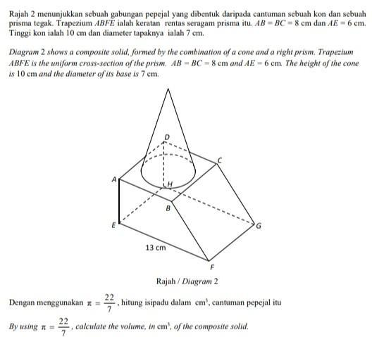
Examples:
- Cone + square pyramid.
- Cone + triangular pyramid.
- Multiple cones and pyramids connected through suitable contact regions.

Pyramid-and-Sphere Composite Solids
# Source: AI Source: Provided by: [Data Path: Persons Table -> ID Column: 1, Name_En Column: Motasem Essam] -> From: [ChatGPT] on [7/25/2026]
These solids combine pyramids with spherical components or spherical sections.
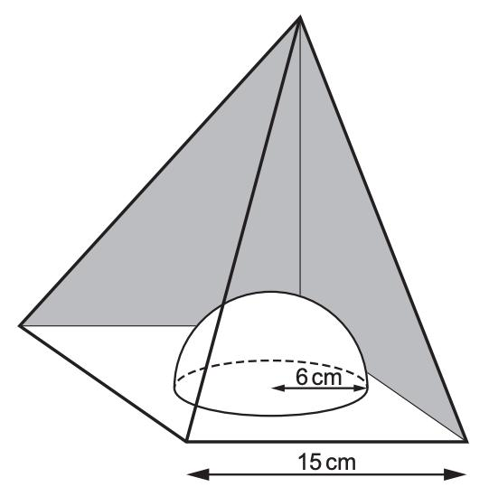
Examples:
- Square pyramid + sphere.
- Pyramid + hemisphere.
- Pyramid + spherical cap.
- Multiple spherical components connected to pyramid faces.

Multi-Type Composite Solids
# Source: AI Source: Provided by: [Data Path: Persons Table -> ID Column: 1, Name_En Column: Motasem Essam] -> From: [ChatGPT] on [7/25/2026]
These solids combine three or more different categories of geometric solids.
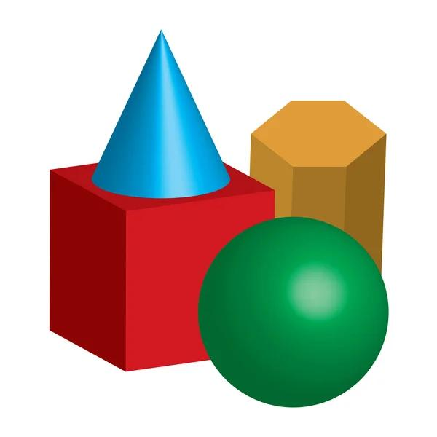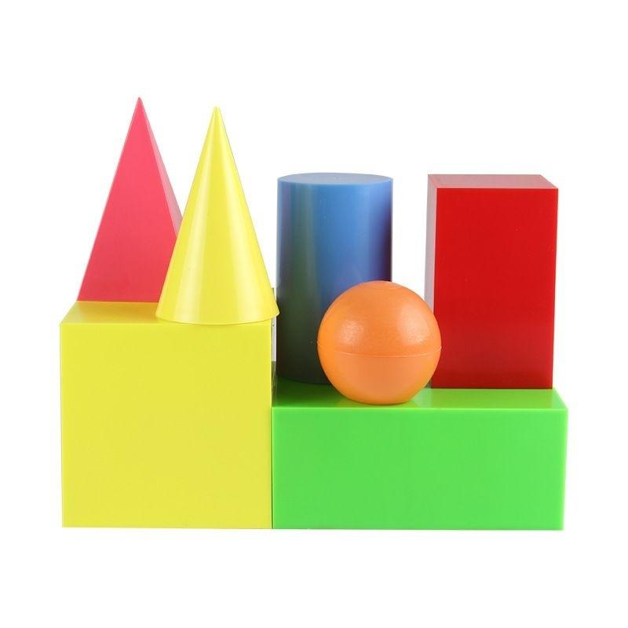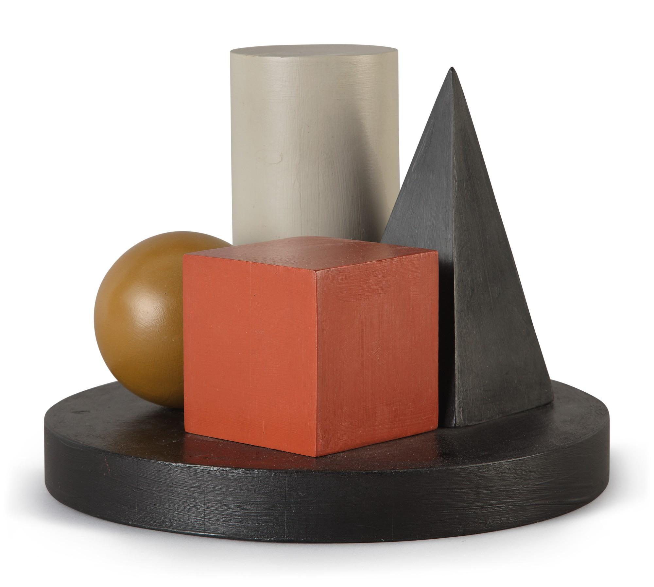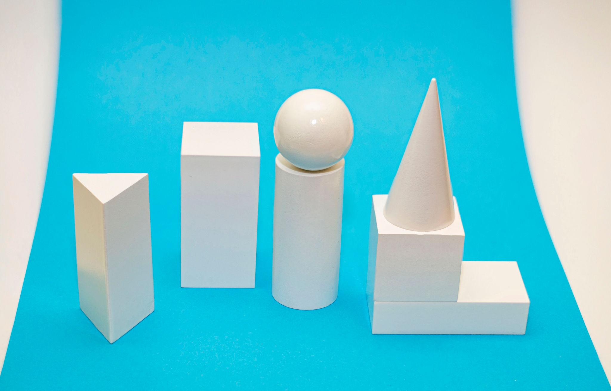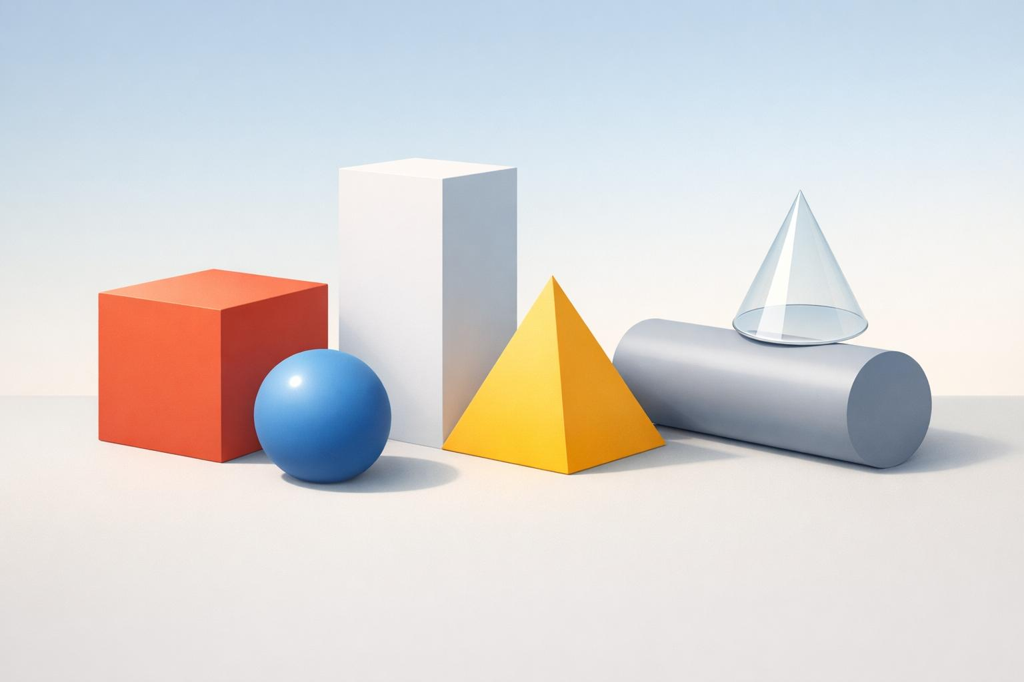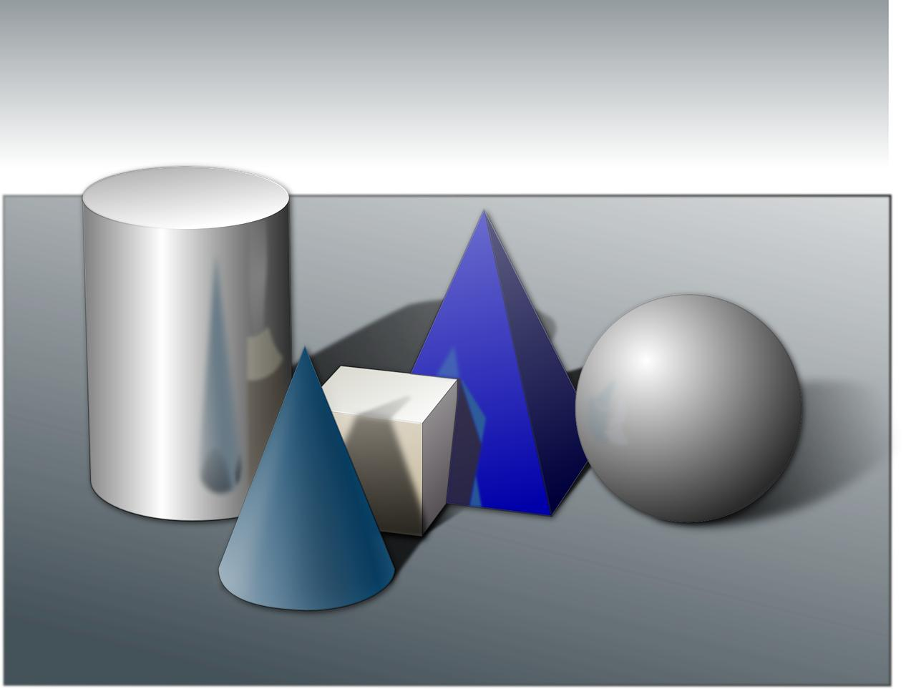
Examples:
- Prism + cylinder + cone.
- Cube + pyramid + hemisphere.
- Cylinder + sphere + cone.
- Prism + pyramid + cylinder + sphere.
- Multiple different solid types arranged into a complex structure.

Classification by Number of Solid Types
# Source: AI Source: Provided by: [Data Path: Persons Table -> ID Column: 1, Name_En Column: Motasem Essam] -> From: [ChatGPT] on [7/25/2026]
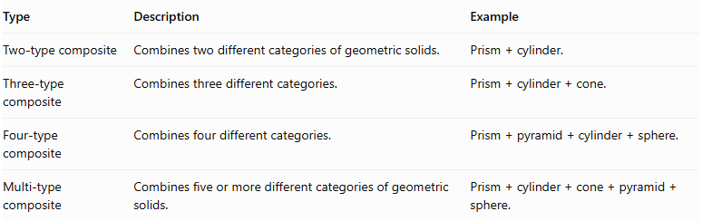
Type | Description | Example
Two-type composite | Combines two different categories of geometric solids. | $$Prism+cylinder.$$
Three-type composite | Combines three different categories. | $$Prism+cylinder+cone.$$
Four-type composite | Combines four different categories. | $$Prism+pyramid+cylinder+sphere.$$
Multi-type composite | Combines five or more different categories of geometric solids. | $$Prism+cylinder+cone+pyramid+sphere.$$

Classification by Joining Arrangement
# Source: AI Source: Provided by: [Data Path: Persons Table -> ID Column: 1, Name_En Column: Motasem Essam] -> From: [ChatGPT] on [7/25/2026]
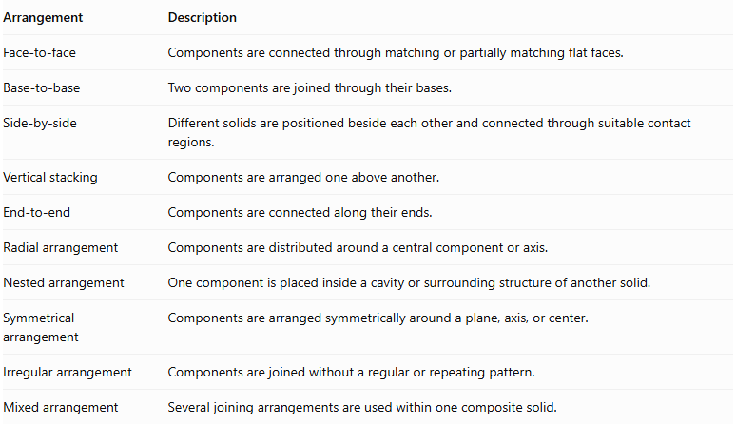
Arrangement | Description
Face-to-face | Components are connected through matching or partially matching flat faces.
Base-to-base | Two components are joined through their bases.
Side-by-side | Different solids are positioned beside each other and connected through suitable contact regions.
Vertical stacking | Components are arranged one above another.
End-to-end | Components are connected along their ends.
Radial arrangement | Components are distributed around a central component or axis.
Nested arrangement | One component is placed inside a cavity or surrounding structure of another solid.
Symmetrical arrangement | Components are arranged symmetrically around a plane, axis, or center.
Irregular arrangement | Components are joined without a regular or repeating pattern.
Mixed arrangement | Several joining arrangements are used within one composite solid.

Classification by Surface Combination
# Source: AI Source: Provided by: [Data Path: Persons Table -> ID Column: 1, Name_En Column: Motasem Essam] -> From: [ChatGPT] on [7/25/2026]
Mixed-shape composite solids can also be classified according to the types of external surfaces they contain.
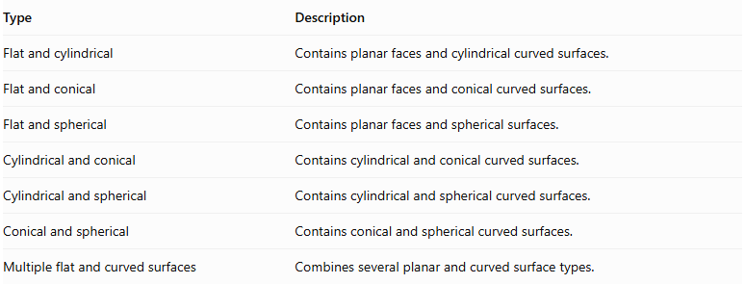
Type | Description
Flat and cylindrical | Contains planar faces and cylindrical curved surfaces.
Flat and conical | Contains planar faces and conical curved surfaces.
Flat and spherical | Contains planar faces and spherical surfaces.
Cylindrical and conical | Contains cylindrical and conical curved surfaces.
Cylindrical and spherical | Contains cylindrical and spherical curved surfaces.
Conical and spherical | Contains conical and spherical curved surfaces.
Multiple flat and curved surfaces | Combines several planar and curved surface types.

Mathematical Properties and Formulas

Volume of a Mixed-Shape Composite Solid
# Source: AI Source: Provided by: [Data Path: Persons Table -> ID Column: 1, Name_En Column: Motasem Essam] -> From: [ChatGPT] on [7/25/2026]
The total volume is the sum of the volumes of its components when their interiors do not overlap.
$$V_{total}=V_{1}+V_{2}+⋯+V_{n}$$
Useful component volume formulas:
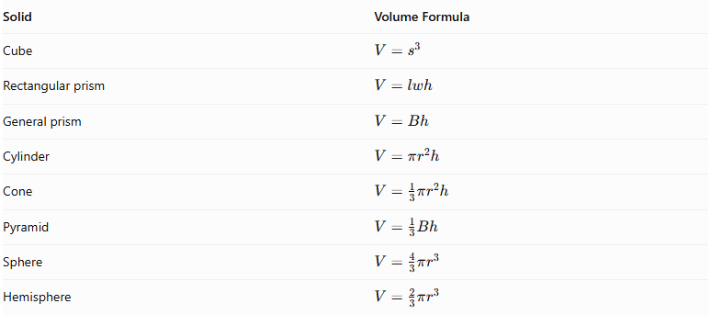
Solid | Volume Formula
Cube | $$V=s^{3}$$
Rectangular prism | $$V=lwh$$
General prism | $$V=Bh$$
Cylinder | $$V=πr^{2}h$$
Cone | $$V=\frac{1}{3}πr^{2}h$$
Pyramid | $$V=\frac{1}{3}Bh$$
Sphere | $$V=\frac{4}{3}πr^{3}$$
Hemisphere | $$V=\frac{2}{3}πr^{3}$$
Where:
- $B$ = area of the base.
- $s$ = cube side length.
- $l,w,h$ = rectangular prism dimensions.
- $r$ = radius.
- $h$ = perpendicular height.
For overlapping components, use the union-volume principle:
$$V(AcupB)=V(A)+V(B)-V(AcapB)$$
For more than two components, account for all overlapping regions without double-counting.

Surface Area of a Mixed-Shape Composite Solid
# Source: AI Source: Provided by: [Data Path: Persons Table -> ID Column: 1, Name_En Column: Motasem Essam] -> From: [ChatGPT] on [7/25/2026]
The external surface area is the sum of all exposed surfaces of the component solids.
$${SA}_{total}=\sum{{SA}_{exposed,i}}$$
For two components joined through a complete matching planar face:
$${SA}_{total}={SA}_{1}+{SA}_{2}-2A_{contact}$$
For multiple full-face joining interfaces:
$${SA}_{total}=\sum{{SA}_{i}}-2\sum{A_{contact}}$$
This subtraction method applies to fully shared planar interfaces. For partial contacts, curved intersections, or overlapping components, calculate the actual exposed boundary rather than automatically subtracting twice the contact area.

Important Surface Area Formulas
# Source: AI Source: Provided by: [Data Path: Persons Table -> ID Column: 1, Name_En Column: Motasem Essam] -> From: [ChatGPT] on [7/25/2026]
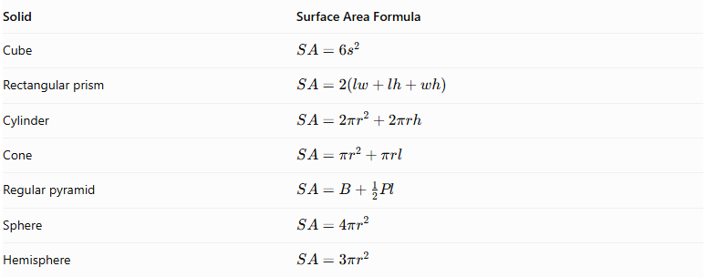
Solid | Surface Area Formula
Cube | $$SA=6s^{2}$$
Rectangular prism | $$SA=2(lw+lh+wh)$$
Cylinder | $$SA=2πr^{2}+2πrh$$
Cone | $$SA=πr^{2}+πrl$$
Regular pyramid | $$SA=B+\frac{1}{2}Pl$$
Sphere | $$SA=4πr^{2}$$
Hemisphere | $$SA=3πr^{2}$$
For a cone or regular pyramid, $l$ represents slant height. For a hemisphere, the formula includes its flat circular base; exclude that base when it is hidden inside the composite solid.

Worked Examples

Example 1: Rectangular Prism with a Cylinder on Top
# Source: AI Source: Provided by: [Data Path: Persons Table -> ID Column: 1, Name_En Column: Motasem Essam] -> From: [ChatGPT] on [7/25/2026]
Given:
- Rectangular prism length = $10 cm$.
- Width = $8 cm$.
- Height = $4 cm$.
- Cylinder radius = $2 cm$.
- Cylinder height = $5 cm$.
The cylinder is placed on the top face of the rectangular prism, with its circular base completely inside the rectangular top face.
Step 1: Calculate the rectangular prism volume.
$$V_{prism}=lwh$$
$$=10×8×4=320{ cm}^{3}$$
Step 2: Calculate the cylinder volume.
$$V_{cylinder}=πr^{2}h$$
$$=π(2)^{2}(5)=20π{ cm}^{3}$$
Step 3: Calculate the total volume.
$$V_{total}=320+20π$$
$$\boxed{V_{total}≈382.83{ cm}^{3}}$$
Step 4: Calculate the rectangular prism surface area.
$${SA}_{prism}=2(lw+lh+wh)$$
$$=2(80+40+32)=304{ cm}^{2}$$
Step 5: Calculate the exposed surface area.
The cylinder covers a circular region on the prism's top face. Its bottom circular face is also hidden.
Exposed prism surface:
$$304-4π$$
Cylinder's curved lateral surface and top base:
$$2πrh+πr^{2}$$
$$=20π+4π=24π$$
Total external surface area:
$${SA}_{total}=304-4π+24π$$
$$\boxed{{SA}_{total}=304+20π≈366.83{ cm}^{2}}$$
<badge color="success">Final result</badge>
- Total Volume ≈ $382.83{ cm}^{3}$
- External Surface Area ≈ $366.83{ cm}^{2}$

Example 2: Cylinder with a Cone on Top
# Source: AI Source: Provided by: [Data Path: Persons Table -> ID Column: 1, Name_En Column: Motasem Essam] -> From: [ChatGPT] on [7/25/2026]
Given:
- Cylinder radius = $3 cm$.
- Cylinder height = $6 cm$.
- Cone radius = $3 cm$.
- Cone height = $4 cm$.
The cone is placed on top of the cylinder, sharing the same circular base.
Step 1: Calculate the cylinder volume.
$$V_{cylinder}=πr^{2}h$$
$$=π(3)^{2}(6)=54π$$
Step 2: Calculate the cone volume.
$$V_{cone}=\frac{1}{3}πr^{2}h$$
$$=\frac{1}{3}π(3)^{2}(4)=12π$$
Step 3: Calculate the total volume.
$$V_{total}=54π+12π$$
$$\boxed{V_{total}=66π≈207.35{ cm}^{3}}$$
Step 4: Calculate the cone slant height.
$$l=\sqrt{r^{2}+h^{2}}$$
$$=\sqrt{3^{2}+4^{2}}=5 cm$$
Step 5: Calculate the external surface area.
The exposed surfaces are:
- Cylinder's curved lateral surface.
- Cylinder's bottom circular base.
- Cone's curved lateral surface.
Cylinder lateral surface:
$$2πrh=2π(3)(6)=36π$$
Cylinder bottom base:
$$πr^{2}=9π$$
Cone lateral surface:
$$πrl=π(3)(5)=15π$$
Therefore:
$${SA}_{total}=36π+9π+15π$$
$$\boxed{{SA}_{total}=60π≈188.50{ cm}^{2}}$$
<badge color="success">Final result</badge>
- Total Volume ≈ $207.35{ cm}^{3}$
- External Surface Area ≈ $188.50{ cm}^{2}$

Important Characteristics
# Source: AI Source: Provided by: [Data Path: Persons Table -> ID Column: 1, Name_En Column: Motasem Essam] -> From: [ChatGPT] on [7/25/2026]
- Different Solid Types: Contains two or more different categories of geometric solids.
- Variable Components: Components may differ in shape, dimensions, and orientation.
- Multiple Surface Types: Can contain planar, cylindrical, conical, pyramidal, and spherical surfaces.
- Complex Structures: Can produce simple or highly complex three-dimensional structures.
- Different Joining Methods: Components can be connected through bases, lateral faces, or partial contact regions.
- Volume Addition: Component volumes are added when their interiors do not overlap.
- Surface Area Calculation: Only exposed external surfaces are included.
- Flexible Arrangements: Components can be stacked, connected side-by-side, arranged radially, or combined irregularly.
- Variable Symmetry: The resulting structure may be symmetrical or asymmetrical.
- Multiple Geometric Properties: Different component types contribute different geometric properties and formulas.

Comparison with Other Types of Composite Solids
# Source: AI Source: Provided by: [Data Path: Persons Table -> ID Column: 1, Name_En Column: Motasem Essam] -> From: [ChatGPT] on [7/25/2026]
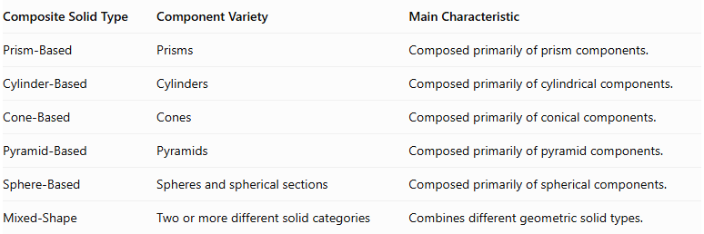
Composite Solid Type | Component Variety | Main Characteristic
Prism-Based | Prisms | Composed primarily of prism components.
Cylinder-Based | Cylinders | Composed primarily of cylindrical components.
Cone-Based | Cones | Composed primarily of conical components.
Pyramid-Based | Pyramids | Composed primarily of pyramid components.
Sphere-Based | Spheres and spherical sections | Composed primarily of spherical components.
Mixed-Shape | Two or more different solid categories | Combines different geometric solid types.

Applications
# Source: AI Source: Provided by: [Data Path: Persons Table -> ID Column: 1, Name_En Column: Motasem Essam] -> From: [ChatGPT] on [7/25/2026]
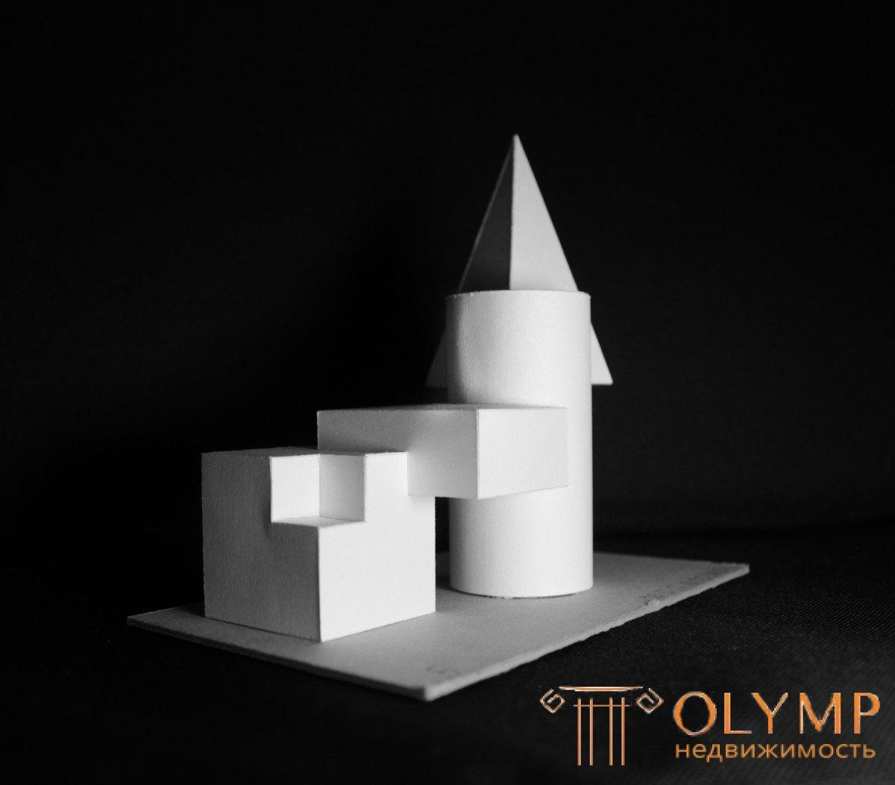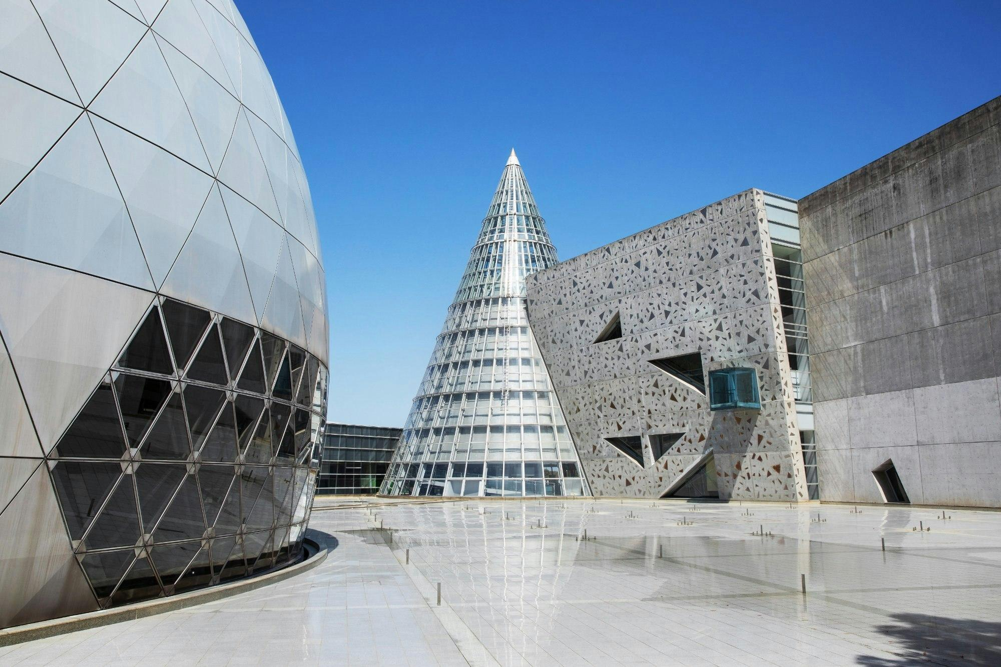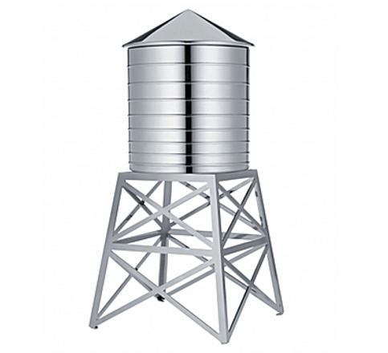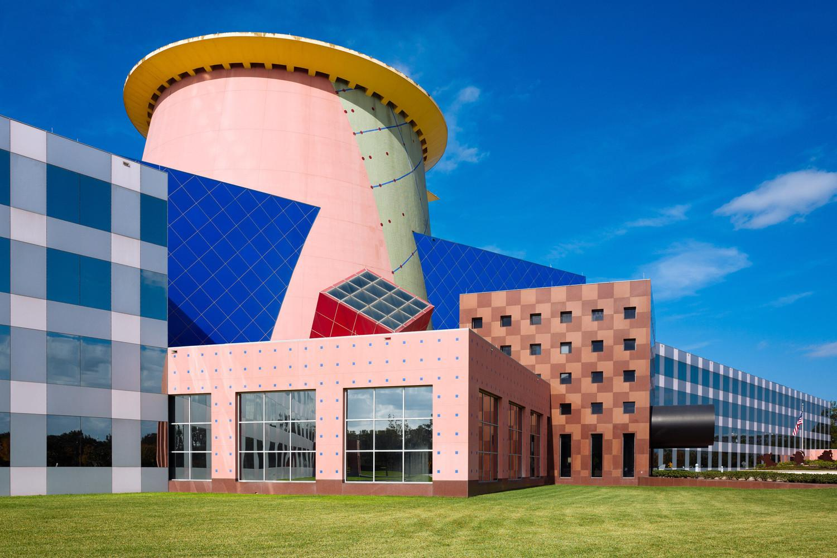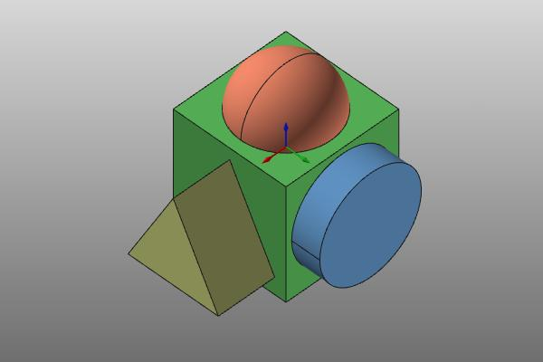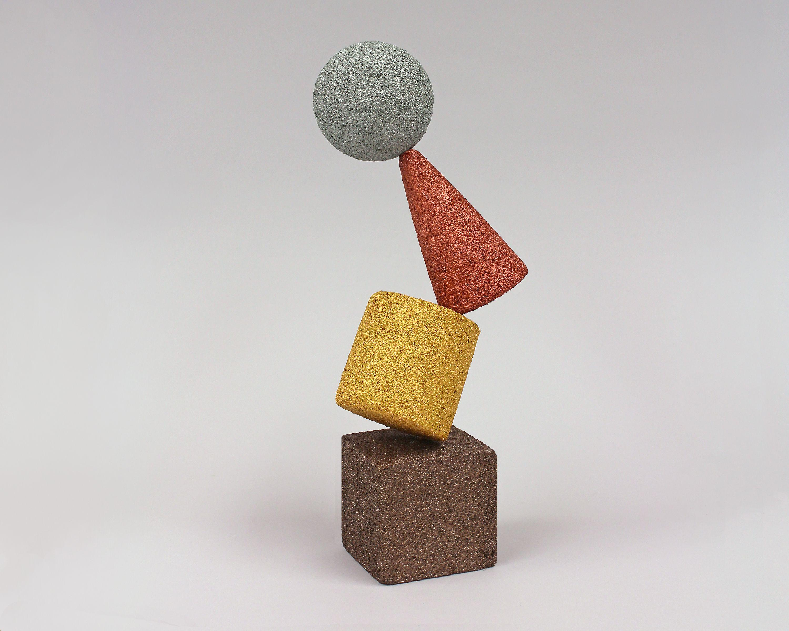
Mixed-shape composite solids are used in several fields:
- Architecture: Buildings combining rectangular structures, cylindrical towers, domes, and pyramid-shaped roofs.
- Engineering: Mechanical assemblies containing cylinders, prisms, cones, and spherical components.
- Industrial Design: Machines, equipment housings, and manufactured products.
- Construction: Structures combining different geometric components for functional and decorative purposes.
- Product Design: Furniture, containers, toys, and decorative objects.
- Computer Graphics: Modeling complex objects using combinations of basic geometric solids.
- Mathematical Education: Teaching solid decomposition, volume calculations, and surface area analysis.

Key Points
# Source: AI Source: Provided by: [Data Path: Persons Table -> ID Column: 1, Name_En Column: Motasem Essam] -> From: [ChatGPT] on [7/25/2026]
- Mixed-shape composite solids combine two or more different categories of geometric solids.
- Their components may include prisms, cylinders, cones, pyramids, spheres, and hemispheres.
- They can be classified by component types, number of solid categories, joining arrangement, and surface combination.
- Their external boundaries may contain several different types of flat and curved surfaces.
- Total volume is calculated by adding component volumes and accounting for overlaps.
- External surface area includes only exposed surfaces.
- Hidden joining faces must be excluded from surface area calculations.
- Each component requires the appropriate geometric volume and surface area formulas.

Conclusion
# Source: AI Source: Provided by: [Data Path: Persons Table -> ID Column: 1, Name_En Column: Motasem Essam] -> From: [ChatGPT] on [7/25/2026]
Mixed-Shape Composite Solids represent one of the most versatile categories of composite solids formed by addition. They combine different geometric solid types into a single three-dimensional structure.
Unlike composite solids based on only one solid category, mixed-shape composite solids allow a wide variety of combinations and arrangements. Their study involves identifying individual components, understanding their joining regions, calculating total volume, and determining the exposed external surface area.
They provide an important foundation for analyzing complex geometric structures in mathematics, architecture, engineering, and three-dimensional modeling.

